Ideation Phase
Empathize & Discover
Date | 09 July 2026
Team ID | -------------
Project Name | Shopezz – MERN E-Commerce Platform
Maximum Marks | 4 Marks

Empathy Map Canvas
An empathy map helps understand the behaviour, needs, expectations, and pain points of Shopezz users. It assists in designing a user-friendly and reliable e-commerce platform.
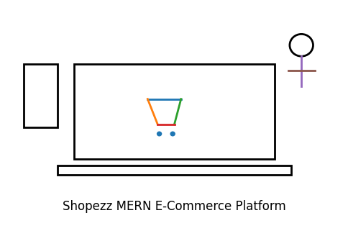

Think & Feel
- Wants genuine products at affordable prices.
- Expects secure payments and fast delivery.
- Prefers a simple and responsive shopping experience.
- Looks for offers and trusted reviews.

See
- Different e-commerce websites and discounts.
- Product ratings, reviews, and recommendations.
- Trending products and seasonal offers.

Hear
- Recommendations from friends and social media.
- Influencer reviews and customer feedback.
- Advertisements and promotional offers.

Say & Do
- Searches and compares products.
- Adds items to cart or wishlist.
- Places orders and tracks deliveries.
- Shares reviews after purchase.

Pain
- Fake products or unreliable sellers.
- Delayed deliveries.
- Complicated checkout process.
- Limited payment methods.

Gain
- Easy product search.
- Secure online payments.
- Fast delivery and easy returns.
- Personalized shopping experience.

